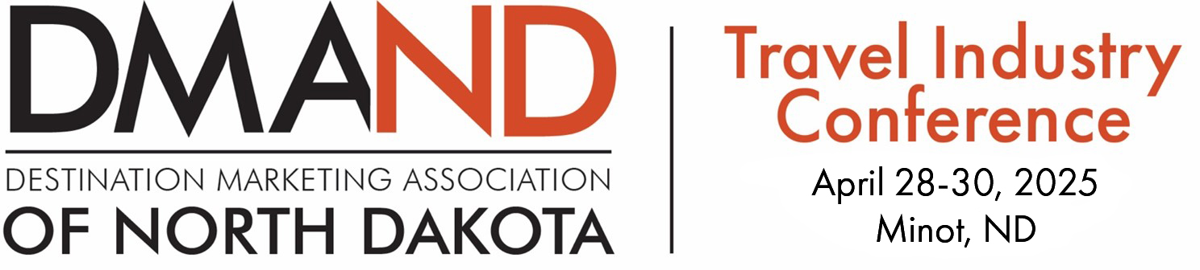

2025 ND Travel Industry Conference Registration Grant Application
Name:
Address:
Phone:
Email:
Agency Represented:

- How can tourism in ND benefit from your community or business?

- What do you hope to gain from this Conference?

- Explain the need for the grant.

- How will your continued and future involvement in the Tourism industry be assisted by this grant opportunity?

Annual Criteria
- Grants will be awarded annually.
- Selection committee will be made up of members from Destination Marketing Association of ND (DMAND).
- Grants will be awarded for Early Bird registration rates only. If you have already paid your registration, you will be reimbursed if your application is granted.
- Priority given to entities that haven’t applied within the last three years.

- Deadline: Grant Applications will not be accepted after Friday, March 7, 2025.

Please mail or email to:  Doug Bolken | Amy Krueger | Suzie Kenner
Wateford City Tourism | Williston CVB | Devils Lake Tourism
100 2nd Ave SW | 212 Airport Rd | PO Box 879
Watford City, ND 58854 | Williston, ND 58801 | Devils Lake, ND 58301
Dbolken@co.mckenzie.nd.us | amyk@ci.williston.nd.us | suzie@devilslakend.com

